9/11 & 20 SHEKELS OF FOOD
Today is the 22nd day of the 2nd month on our Maker’s restored calendar.
It is 23rd day of the 4th month on His servant satan’s calendar.
It is the 211th day of the 440 days that follow the 1,260 days of the Most High’s 42 month witness against the scattered descendants of Israel.
It is the 29th Sabbath into these 440 great and fearful days.
This period of time began on the 8th day Sabbath that follows the 7 days of His Feast of Huts.
440 days is 8- 55’s.
It is 40- 11’s.
The Most High’s Haggai chapter 2 signature ring that He has put upon His end time Elijah’s hand is summed up by the word of His mouth in Isaiah 55:11.
The symbolisms like this that He has paralleled this 440 day period of time with are incredible.
The other day someone sent me an email that illustrates how the chief seat of the scattered descendants of Israel’s 20 dollar bill depicts some of the events of 9/11 on it.
The way that it does so is pretty amazing.
And these 3 illustrations that I am going to share with you testify that the Almighty’s hand was responsible for the events that happened on that day.
What I am going to show you is a result of first taking a $20 bill and folding it in half length wise.
Then fold it again in the following manner;
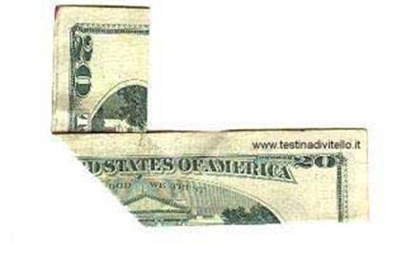
And then fold it again a 3rd time like this;
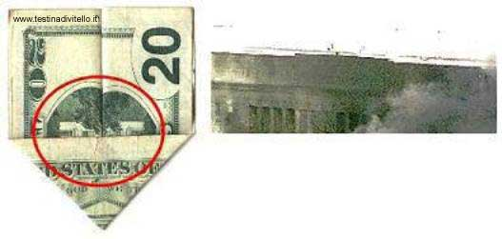
As you can see when you do so it depicts the aftermath of the pentagon being hit that day.
And if you turn this 3 times folded $20 bill over it depicts the aftermath of the world trade center being hit by the two planes that flew into it.
Here is what the flip side looks like;
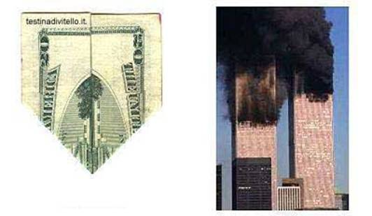
Here is a 3rd thing that a folded $20 bill depicts;
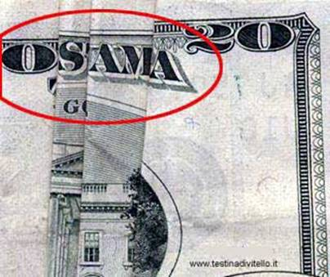
I can assure you that Osama bin Laden was just a pawn in the Most High’s almighty hands on this day.
9 plus 11 equals 20.
Are these things just coincidences?
Is it a coincidence that the Most High’s word tells us that He was going to send His end time son of man to us with a prophecy that includes me eating 20 shekels worth of food per day for the 390 days of the 430 days of His Ezekiel chapter 4 son of man prophecy?
I’ll read this instruction to you;
Ezekiel 4
9 Take wheat and barley and beans and lentils and millet and spelt with you and give them “INTO ONE VESSEL” and make yourself bread with them for the number of the days that you shall lie down upon your left side AND YOU SHALL EAT 390 DAYS.
This one vessel is a prophecy that is for the Most High’s one end time servant that He was going to send to us at this time.
It is also symbolic of you bringing in the heaps into His one storehouse at this time.
The 3rd tier of these 390 days that He has woven into His end time timeline ushers in the one great day of other prophecies.
And this one day will be followed by the pouring out of the 7 vials of the 7th trumpet.
10 And the food that you shall eat shall be by weight, 20 SHEKELS A DAY FROM A TIME UNTIL A TIME you shall eat.
11 And you shall drink waters by measure, 1/6th PART OF A HIN FROM A TIME UNTIL A TIME you shall drink.
The symbolism that is contained in these details are discussed in more detail in other videos that are on the repairing the breach site.
The value of the $20 dollar bill at this time is right at about 75 shekels.
YEHWEH’s servant Abraham was 75 years old when He told him to leave the land of his kindred.
The 1,335th day of His servant Daniel’s prophecy was 75 days after the time, times and a half of a time of this prophecy.
The 1,335th day of this prophecy is one of the 4 dates that His word gives to us in His end time son of man prophecies that are for the opening wide of His end time son of man’s mouth.
I received these illustrations of the $20 bill a while back as well; however the Most High did not show me how they parallel His 20 shekels of food prophecy until now.
These 3 planes flying into these 3 buildings were merely small foreshadows of what is soon going to be sent upon those of you that continue in your rebellion to your Maker.
In lieu of your failure to sustain His anointed like He has told you to do and your failure to fill up the depository of His storehouse…
…and in lieu of the 20 shekel prophecy that is for these supplies, I can assure you that it is not a coincidence that these 3 illustrations are found on a $20 bill.
People use these illustrations to make the conspiracy claim that man’s efforts organized these attacks on these buildings and these illustrations.
This is nonsense; man cannot do anything unless the Most High allows for it.
There is no way that the hijackers that day had the ability to cause these 3 planes to hit these 3 buildings with precision that is revealed in the 3 times folding of a $20 dollar bill.
To think that the 3 tier manifestation of this illustration on this bill was orchestrated by man is foolishness, it is absurd.
And to think that these are coincidences is absurd as well.
In a recent video I pointed out that the 15 years that our Maker added to His servant Hezekiah’s life represent the 15 years that followed these events that occurred on 9/11/2001 on His servant satan’s calendar.
When we get to 9/11/2016 there will be 88 days that are left of these 440 days.
This is 8- 11’s.
These 440 days end on the 11th day of the 10th month on our Maker’s restored calendar.
However there is a very, very important waypoint that occurs 10 days earlier on the 1st day of the 10th month.
This is day number one of the 3 days of His servant Hosea’s chapter 6 prophecy.
And the 3rd day of these 3 days is the 390th day of His Ezekiel chapter 4 son of man prophecy.
The one day and the 7 days that will follow this 3rd day will result in this land lying desolate for 40 years.
When His servant that He drew out from the waters of the river in Egypt spoke to our ancestors before they passed over the Jordan on dry ground we are told;
Deuteronomy 1
1 THESE ARE THE WORDS THAT YEHWEH’S SERVANT MOSES SPOKE TO ALL OF ISRAEL on this side of Jordan in the wilderness and in the desert towards the Red Sea between Paran and Tophel and Laban and Hazeroth and Dizahab.
2 THERE ARE 11 DAYS' JOURNEY FROM HOREB TO KADESH-BARNEA BY THE WAY OF MOUNT SEIR.
Is it just a random thing that this 11 day waypoint indicator is recorded here in the beginning of the words of this book of Deuteronomy?
3 And it came to pass IN THE 40th YEAR, IN THE 11th MONTH, ON THE 1st DAY OF THE MONTH that Moses spoke to the children of Israel “ALL” that YEHWEH had commanded unto them (all that He constituted or enjoined to those who would come under His rule);
Is it a random thing that 440 days is 11- 40’s?
Is it a coincidence that His end time son of man (that He has drawn out from the waters at this time, at the time of the 2nd exodus) is in the process of writing these words that His servant that He drew out from the waters spoke (at that time, at the time of the 1st exodus) upon the 46 stones of the rock design of His Altar that He has reared up in the midst of Egypt at this time?
Is it a coincidence that the 1st day of the 3 days of His Hosea chapter 6 prophecy (that is on the 1st day of the 10th month) is exactly 11 months’ journey from the 1st day of the 11th month?
I’ll share some more coincidences with you that parallel the two of your presidents that were shot in the head;
Abraham Lincoln was elected to congress in 1846.
John F. Kennedy was elected to congress in 1946.
Not only are there 46 great stones in the rock design of this Altar, it took 46 years to build the 2nd temple.
Abraham Lincoln was elected president in 1860.
John F. Kennedy was elected president in 1960.
The year 2016 on satan’s calendar is 56 years after 1960.
YEHWEH opened the Ark’s door for His servant Noah and his family to come off it 56 days after He told him to remove the covering.
The significance of the 100 years that separate these 2 sets of events (and even 2 more sets of 100 year parallels to these two presidents that I will go on tell you about) is that the last day of these 440 days is 100 days after this year’s Memorial of Acclamations that most of you erroneously call the Feast of Trumpets.
The Memorial of Acclamations or the Memento of shoutings is the day that YEHWEH brought forth His only begotten Son into the world.
The Most High is going to establish that He has appointed His end time Elijah to be your head; therefore He has appointed me to be your president.
In lieu of the Most High bringing forth the descendants of Israel though His servant Abraham’s seed, I can assure you that it is not a coincidence that one of these two presidents was named Abraham.
And in lieu of my step-daughter Kennedi turning from her rebellion to the Most High and turning to having a heart like Abraham and becoming my daughter, I can assure you that it is not a coincidence that the other of these two presidents is named Kennedy.
When I finished recording this video my daughter told me that her mother wanted to name her Lincoln if she was born a boy.
Both of these presidents were particularly concerned with civil rights.
The Most High has sent me to you declaring that this is not about your civil rights.
It is about that which is right in His dual eyes.
He has sent me telling you that if you do not turn back to that which is right in His eyes, that you do not have the right to live before His faces.
Both of their wives lost their children while living in the white house.
The Most High has sent me telling those of you who are the scattered CHILDREN of Israel that you and your children are going to die if you do not turn back to Him through that which He has restored through His end time president.
In lieu of the Most High appointing me to be your president, I can assure you that it is not a coincidence that 2016 is an election year in the chief seat of the scattered descendants of Israel.
Both of these presidents were shot on a friday.
The 5th day of the 10th month is the beginning of the last 7 days of these 440 days.
Like I said, the 7 vials of the Most High’s 7th trumpet are going to be poured out during these 7 days.
They are going to be poured out upon those of you who do not turn back to your Maker.
The 5th day of the 10th month this year is on a Friday on satan’s calendar.
Both of these presidents were shot in the head.
The Most High has sent His end time president to you clothed in linen to put His mark upon the foreheads of those who will be delivered into the Millennium.
This is recorded in;
Ezekiel 9
4 And YEHWEH said to the man clothed in linen, go through the midst of the city, through the midst of Jerusalem AND SET A MARK upon the foreheads of the men THAT SIGH AND CRY FOR ALL THE ABOMINATIONS that are done in the midst thereof.
If you do not think that those who live in rebellion to our Maker need to be purged from our midst you do not have this mark upon your forehead.
5 And I heard Him say REGARDING THE OTHERS, go after them through the city AND SMITE: LET YOUR EYE NOT SPARE, NEITHER HAVE PITY NOR COMPASSION ON THEM:
6 SLAY UTTERLY THE OLD AND THE YOUNG, BOTH VIRGINS AND WOMEN WITH THEIR FAMILIES: BUT DO NOT COME NEAR ALL MEN WHO HAVE “MY MARK”. AND BEGIN AT MY SANCTUARY; BEGIN WITH THE MEN WHO ARE THE ELDERS THAT STAND BEFORE THE HOUSE OF ISRAEL.
Lincoln's secretary was named Kennedy.
Kennedy's secretary was named Lincoln.
A week before Lincoln was shot he was in Monroe Maryland.
A week before Kennedy was shot he was with Marilyn Monroe.
These details testify that our Maker is able to control every single detail that He chooses to control.
And you are soon going to be shown this.
However it is not a coincidence that from time to time I call my daughter Kennedi my secretary.
Nor is it a coincidence that the Most High is going to remove me from your midst a week before He pours out the 7 vials of His hot indignation upon those of you who do not turn back to Him and receive His mark upon your foreheads.

Both of them were assassinated by southerners.
Both of them were succeeded by southerners named Johnson.
The Most High has established the place that He has placed His name in the southern part of the chief seat of the scattered descendants of Israel.
Andrew Johnson, who succeeded Lincoln, was born in 1808.
Lyndon Johnson, who succeeded Kennedy, was born in 1908.
This is a 3rd 100 year spread in these details that parallels the 100 days from this year’s Memorial of Acclamations that take us to the last day of these 440 days.
And the following is a 4th such 100 year parallel;
John Wilkes Booth, who assassinated Lincoln, was born in 1839.
Lee Harvey Oswald, who assassinated Kennedy, was born in 1939.
I am sure that these are nothing more than a bunch of coincidences.
Maybe you are enough of a conspiracy theory guru that you think that man orchestrated these details instead of the Most High.
There being 4 of these 100 year parallels in these details parallels all of the other tiers of 4 that the Most High has woven into the testimony of His word and into His end time timeline.
When we get to the end of the first 220 days of these 440 days on the 1st day of the 3rd month in just over a week from today we will be 4 months or 120 days from the Memorial of Acclamations.
YEHWEH’s servant Moses was 120 years old when he spoke the words of the book of Deuteronomy to our ancestors on the 1st day of the 11th month in the 40th year.
Both assassins were known by their 3 names.
At least 4 of the 5 men of His Ezekiel chapter 9 son of man prophecy (that He told to go with me) choose to be called by their middle names or their parents chose this for them.
I am not sure about the one that was number 3 of these 5 because he did not share this information with me, however in lieu the Most High’s Almighty hand, I assume that he did so as well.
Both of their names are composed of 15 letters.
In lieu of this, is it a coincidence that 15 years after 9/11 is the same year that the Most High has sent His end time son of man to declare the acceptable day and the year of His vengeance?
Lincoln was shot at a theater that was named Ford.
Kennedy was shot in a car that was named Lincoln that was made by Ford.
When the Most High spit me out of the belly of the great ocean traversing plane in your midst number 3 gave me a ford to drive.
And then when he rebelled against the Most High’s anointed he took this ford back and he left His anointed and his family in the desert like dogs with no transportation.
Abraham Lincoln was shot in a theater and his assassin ran and hid in a warehouse.
Kennedy was shot from a warehouse and his assassin ran and hid in a theater.
The Most High has orchestrated His end time timeline in a way that has flowed into Him commanding those of you that will turn back to Him to sell everything that you have (that you can sell quickly) and to leave the rest behind and to bring what you have into the depository of His house.
Booth and Oswald were both assassinated before their trials.
The Most High has sent me to you declaring the verdict of His death sentence that is upon those of you who bear the mark of your father satan in your right hand and in your forehead.
He has done so before He actually executes this judgment upon you.
Calling 911 is not going to deliver you from what is soon going to be unleashed upon you.
The only thing that will do so is to turn back to having a heart like a certain other Abraham had and still has.
YEHWEH’s servant Abraham obeyed the word of His mouth and he desired His righteousness.
And my daughter Kennedi has turned back to doing the same.
If you fail to do so as she has done, prepare to meet the face of your Maker’s hot indignation.

